ForNextDay() Lecture 1

# Von Neumann Architecture Paragraph

The von Neumann architecture is a computer architecture in which a processing unit that contains an arithmetic logic unit (ALU) and processor registers, a control unit that contains an instruction register and program counter, a memory that stores data and instructions, an external mass storage, and an input and output are all present. This architecture allows for faster computing because it separates memory and storage into different components. Furthermore, it makes programming easier because it allows for iterative calculations to be made. When a programmer needs to repeat a calculation multiple times, he or she can use loops that iterate through different sections of code without having to copy and paste individual lines repetitively.

# The Stored Program Concept Paragraph

The stored program concept, which was first introduced by Jon Von Neumann in the late 1940s, is a concept that refers to the storage of instructions in computer memory to enable it to perform a lot of different tasks in sequence or intermittently. The stored program concept allowed computers to execute instructions from a memory instead of from a hard drive. As computers became more advanced, the stored programs concept was used to store a larger amount of data, and in doing so to increase performance. In the 1990s it was adapted to support a variety of languages, including Java, C, and C++.

# first.c code

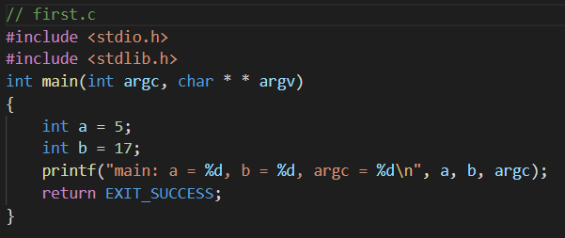

# Terminal Activities

Signing in with sftp to upload first.c

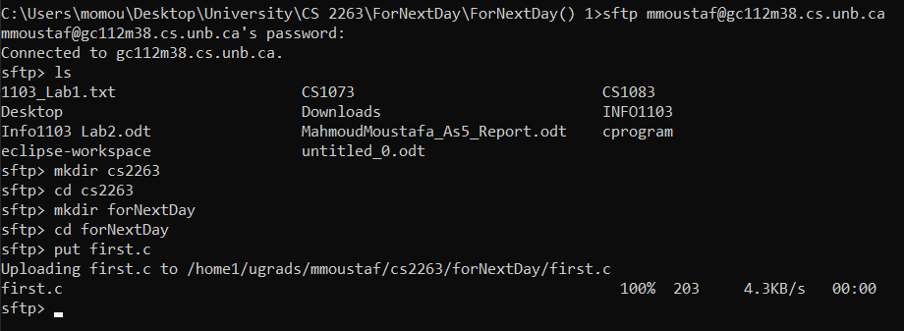

*Signing in with ssh to Compile first.c*

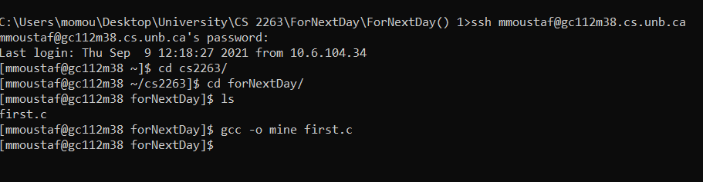

*Running with multiple words*

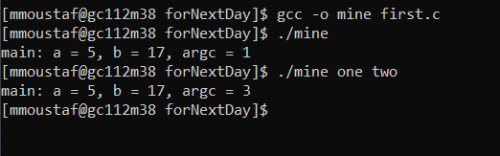

# Explanation of the printf statement

The printf statement is producing a terminal output saying “main : a = 5, b = 17, argc = <a changeable number>” argc is the number of arguments given to the program while running it using the “./”. a = 5 and b = 17 because their values have been explicitly stated (hard coded) in the program. argc changes based on how many arguments are present after the “./”. So, the printf statement prints the hard coded message, along with the values of variables (changing or hardcoded) thanks to the “%d”. Ps. Adding extra spaces between arguments doesn’t make any difference, when there is a space between them.